|  |  |  |
| --- | --- | --- |
| **STLP** | Arrosage Automatique | 01/08/2016 |
| Systèmes : | | |

# Objet

## Description

Ce projet réalise :

* Suivi de la qualité de l’air

## Références

## 

# Nature du projet

Gérer l’arrosage automatique

# Références

## Pompe

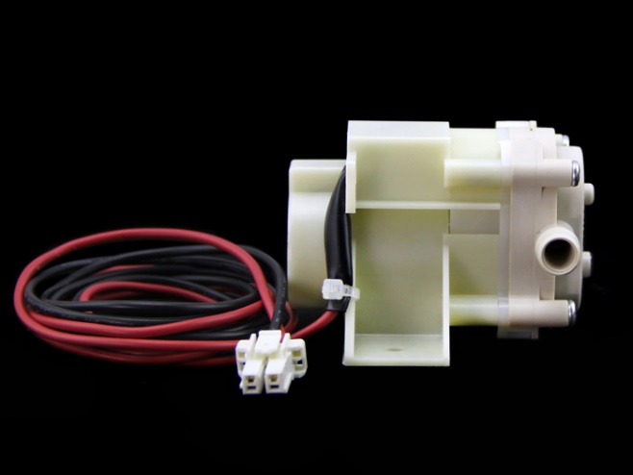

### Spécifications

|  |  |
| --- | --- |
| Working Voltage | DC 10V~13V |
| No Load Current | 250mA |
| Temperature Range | -30~0°C |
| Suction Lift | 100mm |
| Spit Out Lift | 500mm |
| Flow Rate Range | 1.31 ±0.26l/Min |

## Capteur de débit

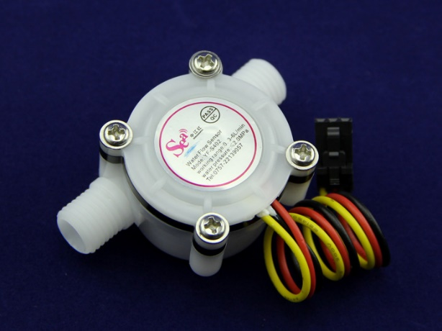

### Spécifications

|  |  |
| --- | --- |
| Mini. Working Voltage | DC 4.5V |
| Max. Working Current | 15mA(DC 5V) |
| Working Voltage | 5V～24V |
| Flow Rate Range | 0.3～6L/min |
| Load Capacity | ≤10mA(DC 5V) |
| Operating Temperature | ≤80℃ |
| Liquid Temperature | ≤120℃ |
| Operating Humidity | 35%～90%RH |
| Water Pressure | ≤2.0MPa |
| Storage Temperature | -25℃～+80℃ |
| Storage Humidity | 25%～95%RH |

### Mechanic Dimensions

Sensor Components

|  |  |  |  |  |
| --- | --- | --- | --- | --- |
| **No.** | **Name** | **Qté** | **Material** | **Note** |
| 1 | Valve body | 1 | PA66+33%glass fiber |  |
| 2 | Stainless steel bead | 1 | Stainless steel SUS304 |  |
| 3 | Axis | 1 | Stainless steel SUS304 |  |
| 4 | Impeller | 1 | POM |  |
| 5 | Ring magnet | 1 | Ferrite |  |
| 6 | Middle ring | 1 | PA66+33%glass fiber |  |
| 7 | O-seal ring | 1 | Rubber |  |
| 8 | Electronic seal ring | 1 | Rubber |  |
| 9 | Cover | 1 | PA66+33%glass fiber |  |
| 10 | Screw | 4 | Stainless steel SUS304 |  |
| 11 | Cable | 1 | 1007 24AWG |  |

### Wiring Diagram

The external diameter of thread the connections use is 1.4mm.

[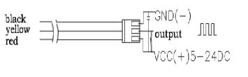](http://www.seeedstudio.com/wiki/File:Wfs-wiring.jpg)

### Output Table

Pulse frequency (Hz) in Horizontal Test= 73Q, Q is flow rate in L/min. (Results in +/- 3% range)

|  |  |
| --- | --- |
| Output pulse high level | Signal voltage >4.5 V( input DC 5 V) |
| Output pulse low level | Signal voltage <0.5V( input DC 5V) |
| Precision | 3% (Flow rate from 1L/min to 10L/min) |
| Output signal duty cycle | 40%～60% |

[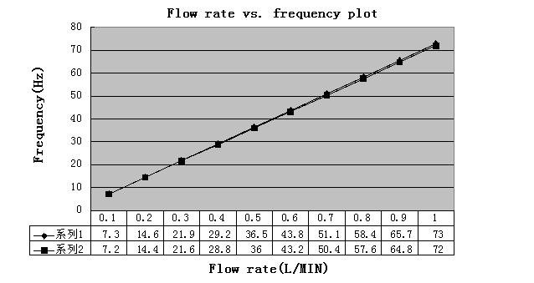](http://www.seeedstudio.com/wiki/File:G14_Flow_rate_to_frequency.png)

## Capteur d’humidité

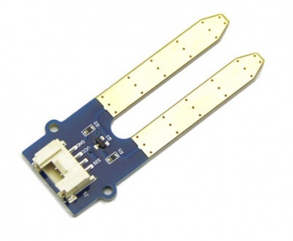

### Spécifications

|  |  |  |  |  |  |
| --- | --- | --- | --- | --- | --- |
| **Item** | **Parameter** | **Min** | **Typical** | **Max** | **Unit** |
| Voltage | - | 3.3 | ~ | 5 | V |
| Current | - | 0 | ~ | 35 | mA |
| Output Value | Sensor in dry soil | 0 | ~ | 300 | / |
| Sensor in humid soil | 300 | ~ | 700 | / |
| Sensor in water | 700 | ~ | 950 | / |

## Capteur d’hygrométrie

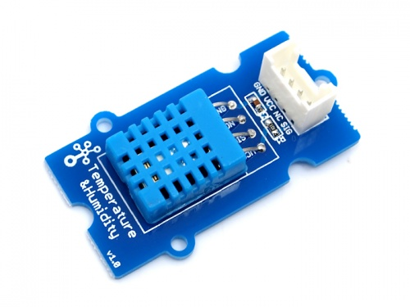

### Spécifications

|  |  |  |
| --- | --- | --- |
| Work Voltage | | 3.3V ~ 5V |
| Measuring Range | Humidity | 20% - 90% RH |
| Temperature | 0 ~ 50 °C |
| Accuracy | Humidity | ±5% RH |
|  | Temperature | ±2°C |
| Sensitivity | Humidity | ±1% RH |
|  | Temperature | 1°C |
| Signal Collecting Period | | 2s |

## Capteur solaire

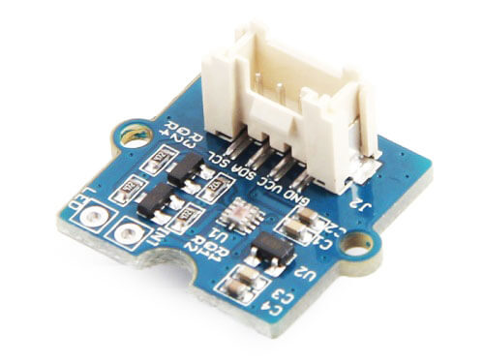

### Spécifications

|  |  |
| --- | --- |
| Operating Voltage | 3.0-5.5V |
| Working current | 3.5mA |
| Wave length | 280-950nm |
| Default I2C Address | 0x60 |
| Operating Temperature | -45-85℃ |

## Affichage OLED

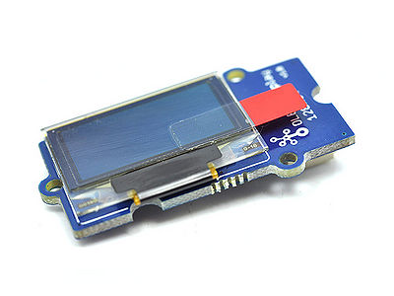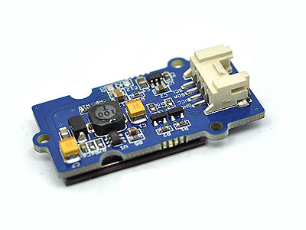

### Spécifications

|  |  |  |  |  |
| --- | --- | --- | --- | --- |
| **Items** | **Min** | **Norm** | **Max** | **Unit** |
| **Power Voltage (VCC)** | 3.3 | 5.0 | 5.5 | V |
| **Driver IC** | SSD1308Z | | | - |
| **Display Color** | White | | | - |
| **Dot Matrix** | 128×64 | | | - |
| **Panel Size** | 26.7(W)×19.26(H) | | | mm |
| **Active Area** | 21.74(W)×11.175 (H) | | | mm |
| **Dot Pitch** | 0.17(W)×0.175 (H) | | | mm |
| **Dot Size** | 0.15(W)×0.15 (H) | | | mm |
| **Wide range of operating temperature** | -20~70 | | | ℃ |

## Panneau solaire

## Batterie

## Chargeur de batterie

## Entrée USB

## Alimentation

# Cahier des charges

### F

#### F

##### F